# Introduction

Human development discourse has increasingly shifted away from traditional economic indicators towards more holistic paradigms with human wellbeing as the primary focus. Amongst these, the Capability Approach (CA), proposed by Nobel Laureate Amartya Sen, is a foundational contribution to this paradigmatic shift. It directs development assessment away from income-based measures towards the real freedoms that people possess to pursue lives they have reason to value. At the centre of the CA are functionings—the different states of being and activities that make up an individual's wellbeing—and capabilities, which refer to the real opportunities or freedoms to attain these functionings. The strategy emphasizes empowering individuals to become autonomous agents in determining their own futures, thereby placing freedom of choice and agency at the centre of development's essential dimensions.

Concurrently, the global development agenda has been influenced by the signing of the Sustainable Development Goals (SDGs)—a collection of 17 global goals defined by the United Nations in 2015, with a specified timeframe for implementation through to 2030. The SDGs cover a wide range of developmental agendas, ranging from poverty eradication, health and education promotion, gender equality, sustainable economic growth, and environmental sustainability. These aspirations express a multi-dimensional concept of development that closely aligns with the values of the Capability Approach, especially their prioritization of inclusiveness, equity, and sustainability.

The purpose of this paper is to investigate where the Capability Approach intersects with the SDGs, with a special emphasis on people's wellbeing as the focal point of development. By choosing Bihar, the Indian state, as the primary context for investigation, the research explores how the overlap of these frameworks actually plays out in reality. Bihar, with its multifaceted socio-economic context and entrenched developmental issues, provides a compelling subject for investigating whether or not policy interventions actually extend people's capabilities and enhance substantive freedoms. From this perspective, the paper seeks to critically evaluate how far recent development activities in Bihar coincide with both the normative foundations of the Capability Approach and the transformative vision of the SDGs.

# Section II: Literature Review & Mechanisms for Achieving Functionings through SDGs

**Mechanism 1**: Promoting Rural MSMEs, Upskilling & MNREGA Reforms  
Linked SDG: Decent Work and Economic Growth (SDG 8)

Multiple studies (e.g., Alkire, 2005; Himanshu et al., 2016) emphasize the role of employment in expanding capabilities. Local micro, small, and medium enterprises (MSMEs) are crucial in enhancing rural employment. Policies that integrate upskilling programs, gig economy platforms, and raise MNREGA wages can ensure livelihood security. This enhances functions such as economic independence, dignity at work, and agency in career choices.

**Mechanism 2**: Community-Based Health Insurance & Digital Health Access

Linked SDG: Good Health and Wellbeing (SDG 3)

Health is the foundation for all other capabilities (Sen, 1993). Ayushman Bharat expansion, digital health record implementation, and community health insurance support can all help to minimize out-of-pocket spending and enhance access. These activities are especially important in rural areas where public healthcare infrastructure is lacking. Improved health allows for activities such as movement, mental well-being, and social participation.

**Mechanism 3**: Subsidizing Education & Linking Curriculum to Skills  
Linked SDG: Quality Education (SDG 4)

Education is a capability enabler with intergenerational impact. Subsidies for higher education, promotion of digital learning (especially in remote areas), and school-based counselling can reduce dropout rates. By aligning school curriculum with local skill needs, education becomes meaningful and functional (UNDP, 2020). This mechanism targets functionings like literacy, employability, and critical thinking.

**Mechanism 4**: NyayaSetu and Mobile-Based Legal Access  
Linked SDG: Peace, Justice, and Strong Institutions (SDG 16)

Many individuals lack access to justice, especially in marginalized regions. The NyayaSetu initiative, combining mobile legal services, AI-based chatbots, and local dispute council improves transparency and swift justice delivery. Ensuring timely legal help strengthens voice, participation, and protection from exploitation. (Nussbaum, 2011).

**Mechanism 5**: Direct Transfers, Local Audits & Inclusive Welfare Delivery  
Linked SDG: Reduced Inequalities (SDG 10)

Economic inequality often results in capability inequality. Mechanisms like Direct Benefit Transfers (DBTs) and tracking schemes through local self-governance increase accountability and eco-political equity. These interventions ensure financial stability, reduce vulnerability, and support social integration of informal workers and women.

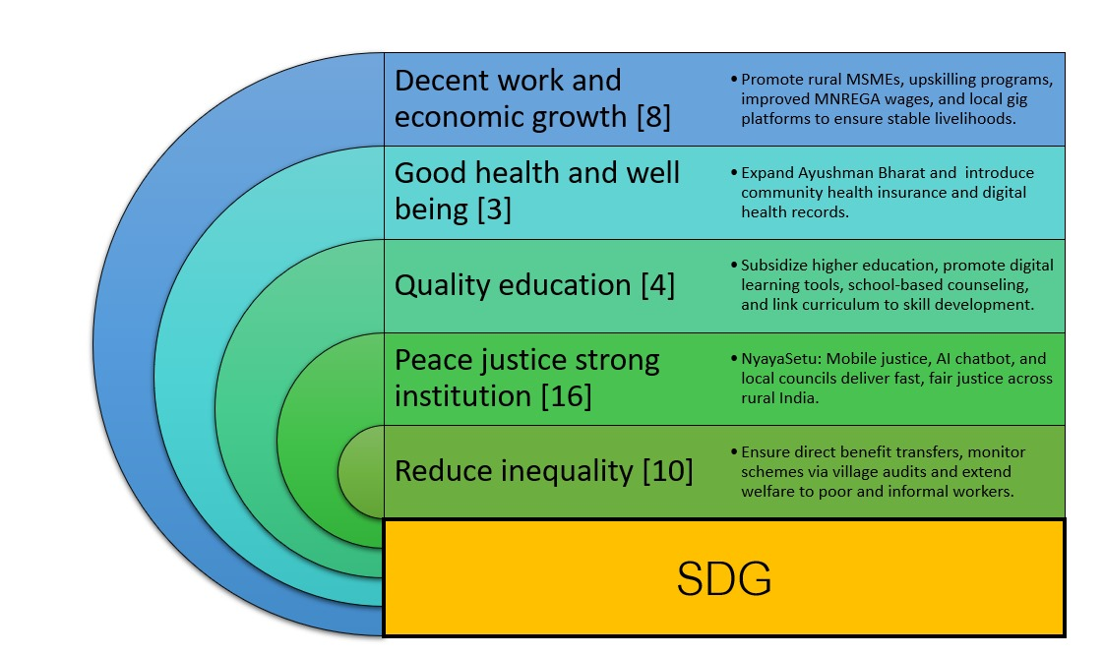

# References:

Alkire, S. (2005). *Why the capability approach?* Journal of Human Development.

Himanshu, Lanjouw, P., Murgai, R., & Stern, N. (2016). *Migration and economic mobility in India: Evidence from the NSS*.

Nussbaum, M. C. (2011). *Creating capabilities: The human development approach*. Harvard University Press.

Sen, A. (1993). *Capability and well-being*. In M. Nussbaum & A. Sen (Eds.), *The quality of life*.

United Nations Development Programme (UNDP). (2020). *Human development report 2020:*